**NAMIBIA UNIVERSITY OF SCIENCE & TECHNOLOGY**



**FACULTY OF COMPUTING AND INFORMATICS**

**DEPARTMENT OF INFORMATICS**

Homateni Elifas: 217151744

Ndamonanghenda Shipena: 201068966

Mateus Iyambo: 217066801

NUST Faculty of Computing and Informatics (FCI) Chatbot

**Abstract**

A Chatbots is a conversational representative that act together with users using natural language. A chatbot permits a user to merely ask a query in a same style that they would talk a human. Chatbots have turn out to be more widespread in business groups now as they reduce customer service cost and handle multiple users at a time. Moreover, making chatbot is a great option for many organizations. This paper grants the proposal of a chatbot, which offers proficient and precise to deliver feedback to students, applicants and anyone requesting information about the faculty of computing and Informatics by the help of machine learning using python.

**Keywords: Chatbot,**

**Introduction**

A chatbot is a computer software that helps in developing a conversation with the user in a natural way and been developed using the concept of Artificial Intelligence. The chatbots are sufficient to fool the users in believing that they're talking to a human being, they've a very limited knowledge base at runtime and have no means to keep track of all the conversations. Chatbots uses machine learning to reach AI for helping them to understand the user queries/doubts and provide the user with an appropriate response. They are developed using the Artificial Intelligence Markup Language for communicating or interacting with the user. Chatbots are often known as answering engines. This application work in a very simple way because the knowledge is already programmed in advance. Few methods used in the application are pattern-matching, natural language processing and data mining. The proposed system would be developed using python. This chatbot system would be developed for NUST Faculty of Computing and Informatics (FCI) to reduces numerous requests during application and registration phases as sometimes, the faculty cannot keep with the load of these requests from the students or parents. It will provide information about FCI programs such as PhD Informatics/Computer Science, Masters (Computer Science, Informatics), Masters Data Science, Honors and bachelor programs

**Related work**

There are many applications that are consolidating a human appearance and are trying to reproduce human exchange, but in majority of cases the information used for conversation in bot are put in the database created by a human specialist. By using AI, we can develop we can develop different types of chatbots, in this paper we have developed NUST Faculty of Computing and Informatics (FCI) Chatbot. (Batu & Wilson, 2017) described a chatbot as the medium of interacting with humans online, where as they're actually interacting with a computer software, put to reality by natural language input. (Kumar, Khan, Manav, Saurav, & Patil, 2018) define it as a computer program which imitates conversation with users, applying artificial intelligence. (Ms.Ch.Lavanya Susanna and R. Pratyusha, 2020) explain that chatbot is a software that permits textual communication using natural language. Furthermore, chatbots will soon become one of the best ways for organizations to get in touch with the individual users and solve their queries quickly (Moore, 2017). According to Guzman 2016, Chatbots are living in task individual applications and duplicating a conversation with a human to enlightening, conversational or esteem based.

**Methods**

NUST Faculty of Computing and Informatics (FCI) Chatbot is developed using chatterbot algorithm that is a python library that makes it easy to generate automated responses to a user's input. This makes it easy for developers to create chatbots and automated conversations with the users. The proposed system is an internet application that provides or delivers feedback to students, applicants and anyone requesting information about the faculty and its programs. Users will put the questions through the chatbot that's used for chatting, questions can be related to the enquiry process, course details, eligibility criteria description, application and registration phases. The answers depend on the user queries. The users do not need to go to the campus for enquiry always. The chatbot examines the inquiry and after that responses to the user. The framework answers to the queries of the user as though it is replied by the individual.

The proposed system simply takes the query from the user which can be students, applicants and visitors, the chatbot will match the queries of the students, applicants and visitors with the knowledge base and the appropriate response. The system will distinguish between a student, applicant and visitor. A student will enter their student number and the systems would know who they are. An applicant also has a student number linked with their application. A visitor has a unique ID. Moreover, the system would provide statistics to FCI management about frequent requests. The Chatbot system answers to the query as if it's answered by the real person. This chatbot guides the all users through the college enquiry process with just a click on the chatbot.

FIG 1 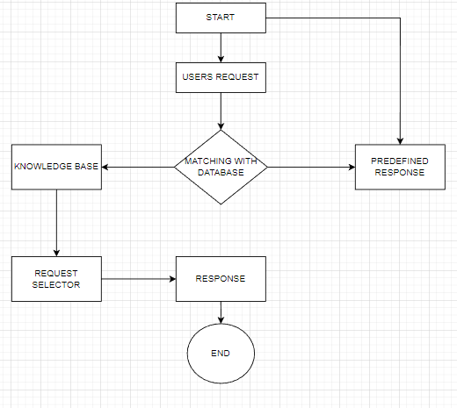

Flow Chart diagram for NUST Faculty of Computing and Informatics (FCI) Chatbot Fig 1.

**Results / Discussion**

The proposed system was successfully tested to show its effectiveness and achievability. It reduces the sweats of the students to travel all the way to campus for enquiry purposes. In this paper we have a developed a chatbot which will interact with the users and provide all the FCI faculty related information. The student, applicant and visitor are interacted through a chatbot. The questions which are not answered by the chatbot will be updated by the faculty admin. The chatbot helps the new students a lot by guide them to different information.

**Input**

The FCI ChatBot develeped usind the keras model consists of multiple components that made up architecture, or configuration, which specifies what layers the model contain, and how they're connected. The Keras API makes it possible to save all of these pieces to disk at once, or to only selectively save everything into a single archive in the TensorFlow SavedModel format (or in the older Keras H5 format) as JSON file. Goog;e collab was used to create a chatbot.

Below are the libriries used to create the chatbot environment

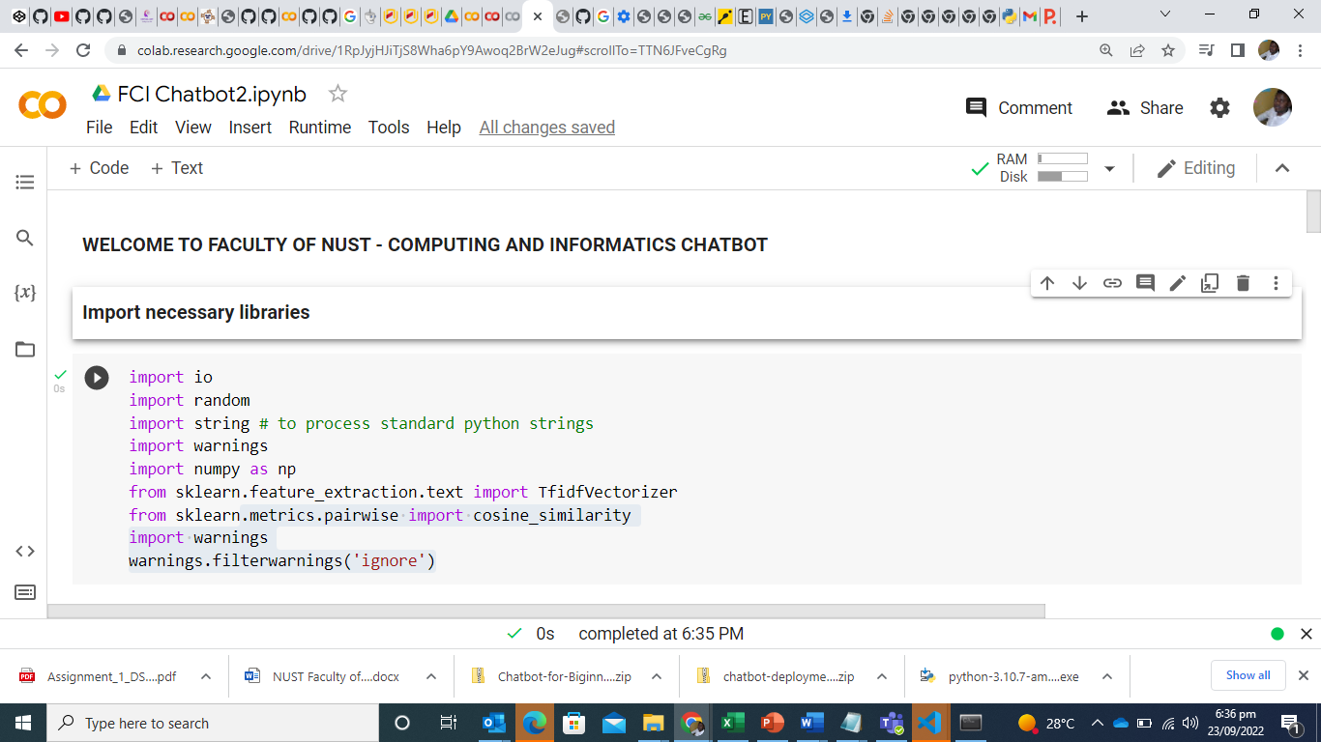

Below: data was scrapped and saved in a form of text, from FCI website to provide feedback and answers to chatbot visteors.

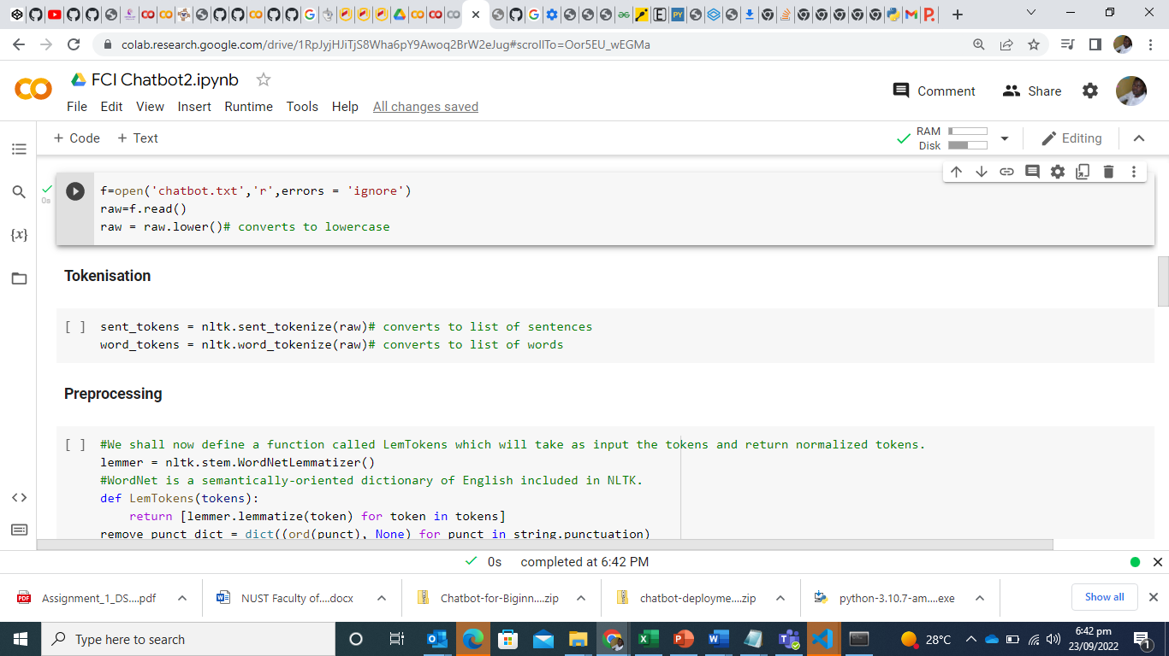

**Output:** Chatbot results

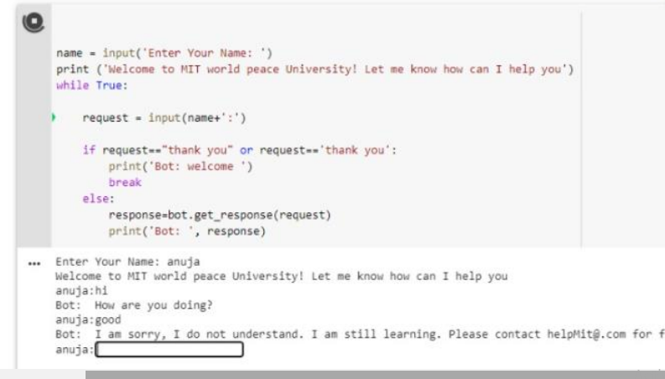

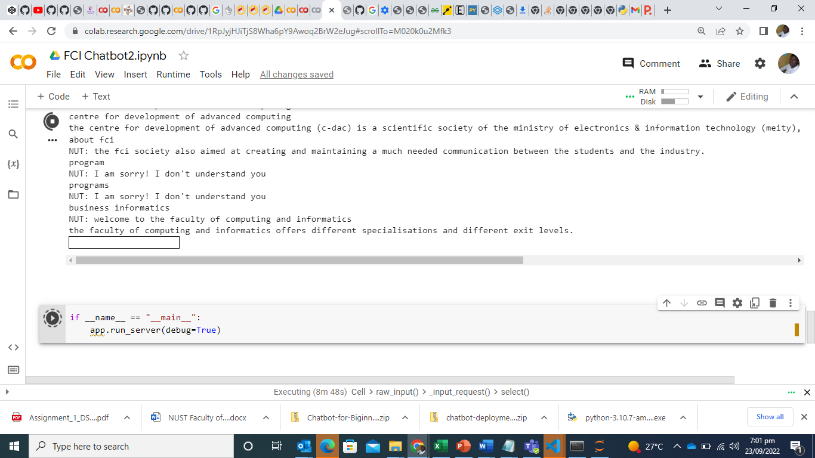

**Conclusion**

The main objective of this chatbot was to develop an algorithm which deliver feedback to students, applicants and anyone requesting information about the faculty and its programs during application and registration phases. We successfully developed a chatbot in which the student, applicant and visitor can ask a query related to FCI programs such as: PhD Informatics/Computer Science, Masters (Computer Science, Informatics), Masters Data Science, Honors and bachelor programs. The system provides statistics to FCI management about frequent requests.

# **References**

Batu, E., & Wilson, G. (2017). CHATBOT FOR COLLEGE ENQUIRY. *International Journal of Creative Research Thoughts*.

Kumar, S., Khan, S., Manav, S., Saurav, V., & Patil, S. (2018). Chatbot for College Website. *International Journal of Computing and Technology*.

Moore. (2017). Chatbot for Student Admission Enquiry. *Advancement in Software Engineering and Testing*.

Ms.Ch.Lavanya Susanna and R. Pratyusha. (2020). COLLEGE ENQUIRY CHATBOT. *International Research Journal of Engineering and Technology (IRJET)* .

https://stackoverflow.com/questions/54828713/working-with-anaconda-in-visual-studio-code

https://github.com/python-engineer/chatbot-deployment